CAPACITORS AND INDUCTORS

Capacitors
A capacitor is basically two metal surfaces separated by an insulator. For capacitors, this insulator is called a dielectric, because of the purpose it has. The dielectric is so thin that the electrostatic field on one plate may be felt across the dielectric and push (or pull) electrons on the other surface. A change in voltage on one plate can be felt as a change in voltage on the other plate, but charges do not actually flow through the dielectric. As we apply a negative voltage on one plate, we push electrons off the other plate, leaving a charge between the plates and the dielectric.
The big debate about capacitors is where the charge is stored. Is it stored in the dielectric, or in the plates? If you are among those who say the charge is stored in the dielectric, then how can we make a capacitor with a vacuum as a dielectric. Since a vacuum has the same capability to act as a dielectric as air, we must admit that the “Charge in the dielectric” story is incomplete, at best.
Without a doubt, with two plates a set distance apart, we can get different ability to storage a charge (called capacitance) by using different material as the dielectric. So there is something to this story. It is just not the whole story.

Capacitance
Getting another old person into the story, Mr. Faraday, got his moment of name recognition on capacitors. The ability to store a charge between conductive plates is called Capacitance, and is rated in Farads. One Farad is a relatively large value, and most capacitors are rated in micro-Farads, or pico-Farads. One Farad is the capacitance required to charge up a 1 Ohm resistor in 1 second.
There is a specific structure to this that is worth paying attention to. T (Time, in seconds) = R (resistance, in ohms) times C (Capacitance, in Farads).

Capacitance is usually rated in 5% or 10% values, and follow the same pattern of numbers as resistors. They are also rated in breakdown voltage. The maximum voltage we can apply before the dielectric decomposes and starts conducting, destructively. Since we need that changing electrostatic field to influence that other plate across the dielectric, capacitors can be said to pass an AC signal, but block DC. If we apply DC to a capacitor, it will charge up, and stay charged.

Different types of capacitor characteristics can be obtained by using different dielectric materials. Ceramic is the cheapest dielectric, and ceramic capacitors are the most popular where quality is not a concern.
Plastic film materials are used as a dielectric for higher quality is required (sound systems). These are called polystyrene, polypropylene, or some variation. They may be metal foil separated by a plastic sheet, or just a plastic sheet coated with a metallic coating.
For high capacitances, we often use a metal oxide for the dielectric. The closer the plates are together, or the larger in area the plates are, the higher capacitance we can get. It is hard to beat a layer of metal oxide for a thin insulator. These have a disadvantage of being sensitive to polarity. The plates are always polarized, one positive, the other negative. Usually only one plate is labeled. Unfortunately, Eastern manufacturers tend to label the Negative side, and Western manufacturers label the Positive side. They must be put into the circuit with the positive side going to the more positive voltage.
If you put one in backwards they tend to explode.
Current technology has increased the capacitance to the point where super capacitors compete with batteries in limited application. Size-for-size a battery can still hold about 100 times the charge of a super-capacitor.
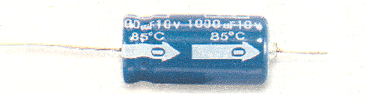
Aluminum Electrolytic capacitors come in an axial case, as shown to the left here, or in a radial case, with both leads coming out of the bottom. These consist of layers of aluminum sheets separated by aluminum oxide. Since the insulator (the oxide) is only a few atomic layers thin (okay, maybe hundreds or thousands of layers) the plates are close together and a high capacitance can be attained in a medium size package. In some of the more modern Super Caps there is even fewer atomic layers and capacitances up into the Farads (instead of micro-Farads) can be attained, but the voltage may only be 3 to 5 volts as a result. These usually come in 20%, or worse, tolerances. The larger the capacitance the worse we get. It isn’t unusual to find a capacitor rated at “-20% / +100%. This means that the actual measured capacitance may be as low as 20% of the rated value, or as high as 100% more than the rated value. Other than Capacitance rating, they are rated in voltage. This indicated the maximum voltage that the capacitor can tolerate. Characteristics also include a temperature range of operation. Most capacitors found in your home stereo are rated for 85 degree (Centigrade) service. Most of them found in monitors will be rated for 105 degree service. They also have an ESR (Effective Series resistance) rating. Low ESR devices are intended for high frequency applications like Switching Voltage Regulators. Electrolytic capacitors usually have a polarity. The negative side of the capacitor must go to the more negative voltage in the circuit it is going in. Eastern markets tend to mark the negative side with a bar or dot. Western markets tend to mark the positive side. Much to our frustration the boards are made by Western standard and the capacitors used are made according to the Eastern standard. PAY ATTENTION WHEN YOU CHANGE THESE CAPACITORS. PUT THEM BACK IN THE SAME WAY THEY CAME OUT.
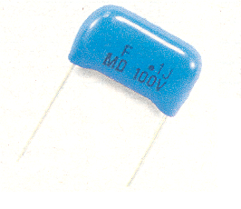
Film capacitors, like the one shown to the left here, are a higher quality than most other capacitors. They are typically rated as 5% or 10%. Other characteristics mentioned also apply. These are usually a metal (aluminum) foil separated by a plastic film, or are a plastic film with metal deposited on it. These are used where a higher quality. Some of them are labeled with a bar at one end. The bar indicates which lead goes to the outside layer. This lead should go towards ground.
Film capacitors also come in axial, radial or surface mount packages. Radial is shown.

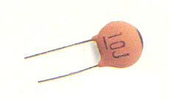
Ceramic capacitors are the simple cheap members of the capacitor family. Ceramic Disk types are little more than a disk of ceramic material with metal paint on both sides. Surface mount devices are of much the same construction, but in rectangular shape. Multi-Layer Ceramic capacitors are layers of sandwiched ceramic material separated by metal painted surfaces. The temperature characteristics can be so poor that these devices can be temperature sensors, or they can be quite high quality. A three character code tells you what temperature characteristics it has. Z5U is common with poor temperature characteristics. C0G (that’s C-zero-G) and NPO (N-P-Oh) are higher quality.

There are many more types than those mentioned. This is intended to be a quick overview of some of the possibilities, not a complete course. This subject is also deserving of a full week’s attention.

Effects of Capacitance
If we apply a square wave DC signal to a resistor and capacitor network as shown below it will influence the signal quite predictably. When the first rise in voltage occurs it will take a while for the capacitor to charge up. The voltage across the capacitor will have a slow rise in its output level.
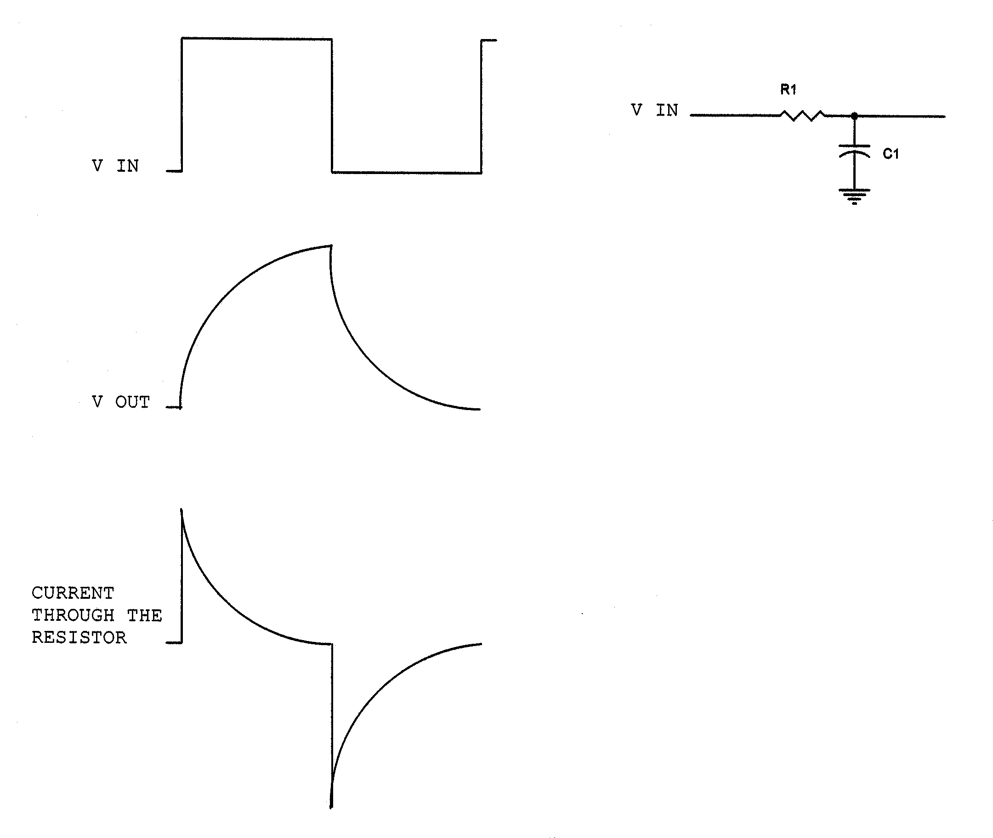
While the capacitor is charging we have a high current through the resistor. As the charge on the capacitor builds up there is less difference in voltage across the resistor and current decreases. When the input voltage drops, the charge built up on the capacitor will discharge equally slowly. Initially there is a surge of current. As the capacitor discharges the current decreases. The influence of the capacitor can change a square wave to the Sawtooth wave as shown above. The capacitor does so because it stores the charge of the applied signal. In this case the output voltage is delayed, but not the current. This brings the discussion to ELI the ICE man. We will get more on that in a minute. As the frequency of the applied signal increases the effective opposition decreases. Resistance opposes all signals equally (in simple theory classes). Capacitors has an opposition that changes with frequency. This quality of a resistance that changes with frequency is called Reactance, and is also measured in Ohms.

Reactance
Resistors (perfect resistors, anyway) have the opposition to current whether it’s AC or DC. Reactance is resistance to AC. Capacitors have a high resistance to DC and a varying resistance (reactance) to AC. As frequency increases capacitive reactance decreases. The formula for capacitive reactance is as follows:

Xc = 1/(6.28x F x C)

Xc is Capacitive reactance, in ohms.
6.28 is actually “2 x pi(3.14159…)”.
F is frequency of the signal, in Hertz.
C is the capacitance, in Farads.

Capacitance is the opposition to a change in Voltage, and Capacitive Reactance decreases as frequency increases. If we apply a DC voltage to a capacitor, we get a quick surge of current as the capacitor charges. Eventually the charge on the capacitor equals the applied voltage, and current stops flowing. When we remove the applied voltage, the charged capacitor discharges, giving a surge of current. This surge must be accounted for in the design to prevent damage to other components, or is often the intended purpose of the circuit.

Inductors, the other reactor.
An inductor is basically windings of wire. As we mentioned earlier, when a current passes through a wire it generates a magnetic field. It is also true that when a magnetic field crosses a wire it induces a voltage in that wire. If we have turns of wire close together the magnetic field generated by current passing through one turn of the coil induces voltages in nearby turns of the coil. As magnetic fields go, the induced voltage tries to force currents in the opposite direction as the original current that caused the original magnetic field. The faster the magnetic field tries to change, the more induced voltages we have trying to make current flow in the opposite direction. This is Inductance, and the opposing voltages appear as opposition to a change in currents as.
Getting another old person into the story, Mr. Henry, got his moment of name recognition on inductors. The ability to store a charge as a magnetic field is called Inductance, and is rated in Henrys. One Henry is a relatively large value, and most inductors are rated in milli-Henrys, or micro-henrys. One Henry is the inductance required to charge up a 1 Ohm resistor in 1 second.
There is a specific structure to this that is worth paying attention to. T (Time, in seconds) = R (resistance, in ohms) times L (Inductance, in Henrys).

Inductance is usually rated in 5% or 10% values, and follow the same pattern of numbers as resistors. They are also rated in current carrying capability. The maximum current the wire can handle before getting too hot. Since we need that changing magnetic field to influence that other windings, inductors can be said to oppose an AC signal, but pass DC. If we apply DC to an inductor, it will charge up a magnetic field as the voltage increases, and stay charged, leaving only the resistance of the wire affecting the current. When the applied voltage stops pushing, the magnetic field collapses, passing through the turns of wire, causing a spike of current heading in the opposite direction as the original current. This spike can be dangerous to the circuit the inductor is connected to, and must be allowed for in the design of the circuit where inductors are used.

An inductor, being made of a simple wire, has little opposition to DC. As frequency increases, Inductive Reactance increases. Just opposite the qualities of a capacitor. The formula for Inductive Reactance is as follows:

XL = 6.28 x F x L
XL is Inductive Reactance, in ohms.
6.28 is 2 x pi
F is the frequency, in Hertz.
L is the inductance, in Henrys.

Inductance is opposition to a change in current, and Inductive Reactance increases as frequency increases.
Reactors are often used in pairs as noise filters on power lines. Quick surges of current (noise) on the power line are fed through an inductor (in series with the line). The inductor opposes the quick change in current. A capacitor (in parallel with the power line) absorbs this quick change in voltage, by absorbing it as a charge. This configuration of a series inductor and a parallel capacitor we will often see used to filter out high frequency noise in a circuit.

ELI the ICE man
Inductors have the opposite influence as capacitors. In Capacitive circuits, a change in current leads a change in voltage. In inductors, a change in voltage leads a change in current. The relationship is easy to remember with the phrase that titles this paragraph.

E means voltage.
I means current.
L implies an inductive circuit.
C implies a capacitive circuit.

ELI – In an inductive circuit Voltage leads Current.
ICE – In a capacitive circuit Current Leads Voltage.

