ITHACA MODEL 850 TICKET PRINTERS

Two different interfaces are used in 850 printers

IGT Netplex
Communication board # E030062-01 (10 pin connector on communication board )
Powered through a 8 pin pigtail connector
Controller board Firmware PE88xx

All Other Game Manufacturers RS232 Serial
Communication board # 85-03526 (14 pin connector on communication board )
Powered through a external power supply
Controller board Firmware PP85xx

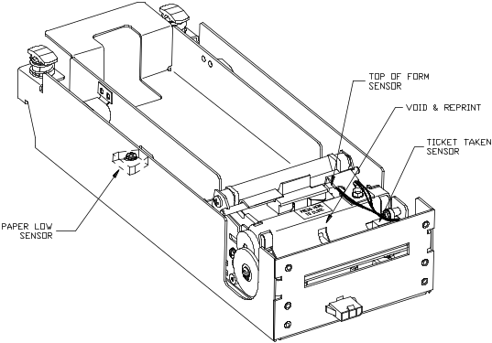
SENSORS & SWITCHES

Open/Close Sensor
Located on communication board. In rear of outer chassis.
Determines if the Printer inner chassis is racked out (open)
See FIG 2.

Paper low Sensor
Optically senses the tickets in ticket tray. Senses 30-35 tickets remaining in ticket tray. Reports paper low to game in the status byte. Verify with Game manufacturer how status byte is managed. See FIG 1.

Top of Form Sensor
Senses black dot on right edge of ticket. See FIG 1.

Ticket Taken Sensor
Used to determine when customer has removed the printed ticket. See FIG 1.

Head-Up Switch
Signals when thermal printhead assembly has been opened.
Located under the printhead, not visible from the top of printer

Ticket Feed Switch
Located on controller board operated by Feed Button.
See FIG 3.
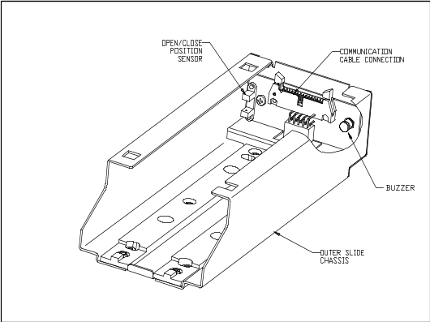
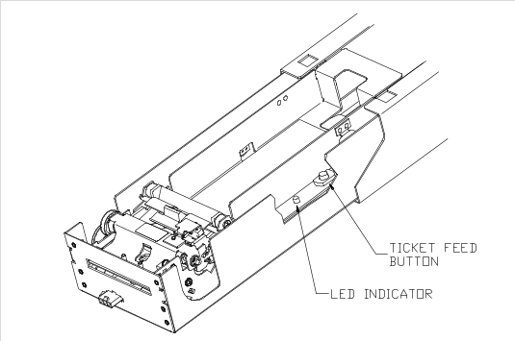
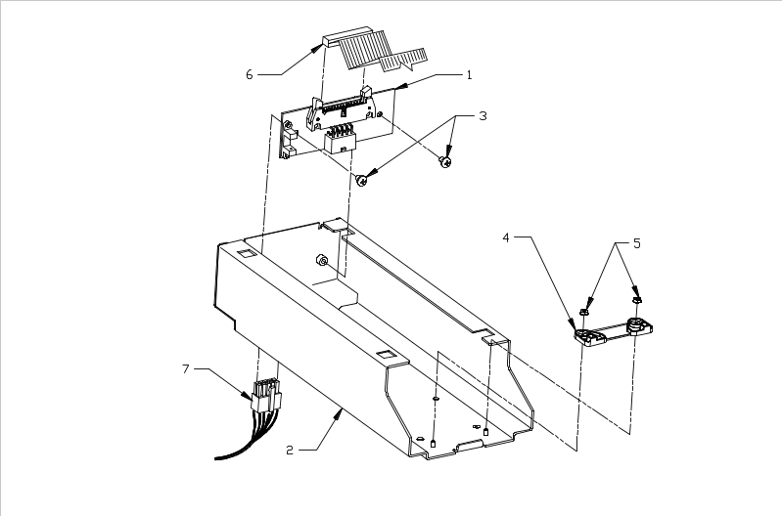
Gray 30 pin flex cable
IGT 10 pin
WMS 14 pin
Communication Brd

FIG 1
FIG 2
FIG 3

Stand-Alone

Print Test Ticket

REMOVE POWER
IGT – Power down the game.
WMS - external power supply

Rack out printer assy.
Block open /close position sensor.
( RS232 printer ) See FIG 2.

Hold down ticket feed button. See FIG 3.
Apply power.

Ticket prints.

Printer Status LED
The printer has been outfitted with a LED indicator system that provides the condition of the printer by using a series of blinks to communicate the status of the printer. If a customer supplied Bezel is installed, the status of the Bezel will be identical to the LED

The following table lists the different LED indications and provides a brief description.

Condition | Status LED/Bezel
Unit Ready | On
Head Up | Med Blink
Door Open | Med Blink
Paper Out | Slow Blink
Temperature Error | Fast Blink
Paper Jam | 4 Blinks Pause
Ram Error | 2 Blinks Pause
Checksum Error | 5 Blinks Pause

TROUBLESHOOTING

Error on IGT game screen
“Wrong type of paper” and printer buzzer beeping. This is caused by the ticket perforation not breaking as the customer takes ticket pulling the leading edge of the next ticket passed the top form and under the ticket taken sensor.
To clear error reload ticket.

Ticket won’t load on IGT game
Printer will have to power cycled or the game rebooted.
To clear error Reboot the game.

Gray 30 pin flex cable getting pinched. Care has to taken when closing the inner slide assy.

CAUTION never unplug the gray 30 pin flex cable with the power on. Damage to the communication board will result.

Ticket Taken Sensor
POSITION OF TICKET AT TOP OF FORM
LOOKING DOWN ON PRINT MECH
ticket
TOF
Lead edge of ticket should be positioned as shown in cutout of platen cover
TTS

TOF

